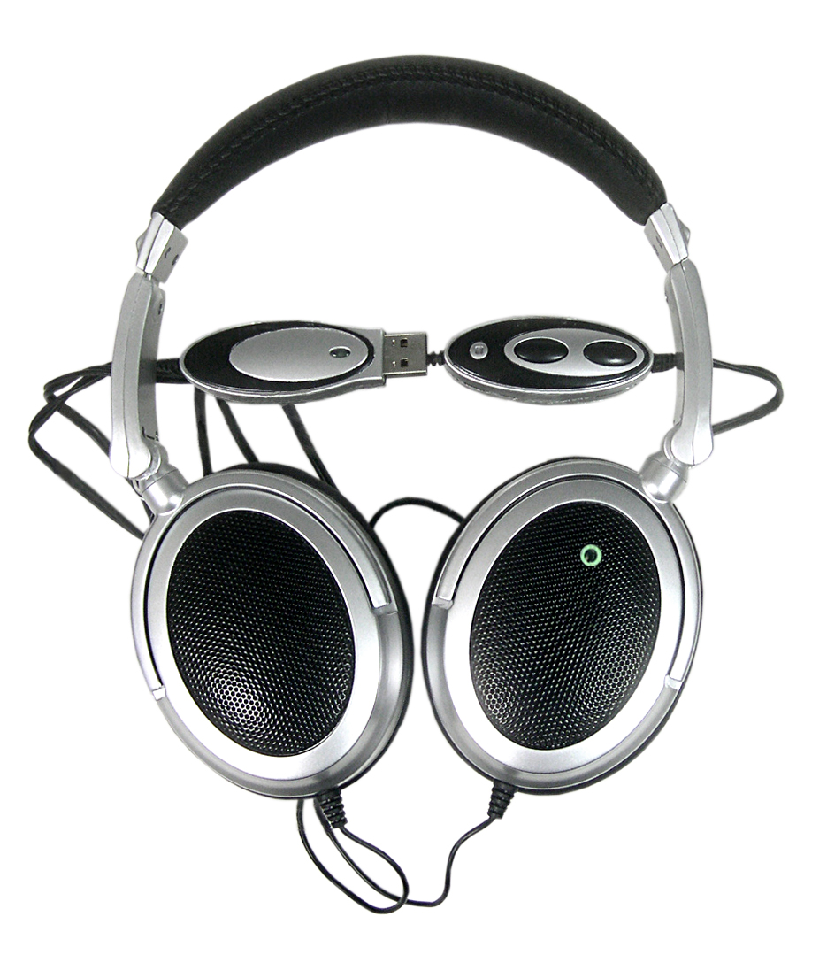

Model Name:
CM106
USB 2.0 True 5.1 Channel
Home Theatre Headphone

Features:
- Total 8 Speakers
- Create 5.1 ch/ 7.1 ch Surrounding Sound
- 12 EQ mode selectors
- Mobile Home Theatre!
- Space Saving!
- USB Interface
- Volume Controller
- Bass Enhancement
- Safe Deep Bass Subwoofer
- Easy Installation, Plug & Play!

Specification:
1) Output (Watt): 15mW Max X 8
2) THD: 3%
3) SNR(dB/V) : 10
4) S/N: > 80 dB
5) Frequency Range: 20-20KHz
6) Speakers:
a.) Front Speaker: Ф U28 x 2 32Ω
b.) Rear Speaker: Ф U15 x 2 16Ω
c.) Center Speaker: Ф U15 x 2 16Ω
d.) Subwoofer: Ф U40 x 2 32Ω

Dimension :
Headphone (L x W x D): 200 x 180 x 50 mm
Headphone Cable: 150 cm
Total Weight :
150± 20g

